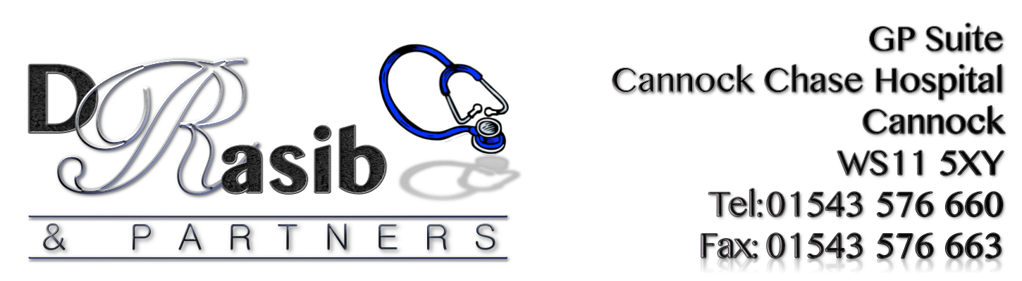
Dear Patient,

In order to help process your request for a letter more efficiently, we would be grateful if you could provide some further information.

Please provide details of the key points you would like mentioning in the letter in the area below. Please refer to the guidance available for fees and Data Protection.
Private Letter Request Form (please write overleaf if needed)

Please provide a date of when you need the letter by: ____________________________________

Please sign and print your name to confirm that you (the patient) give consent for the disclosure of your personal medical information to a third party.

Name of Patient:____________________________ Signature: ___________

Date:____________________

This form will now be processed and you will be advised of the fee.
Payment is required prior to the letter being done.

FOR STAFF USE ONLY: Fee payable £_______ Date paid _______________
Form of patient ID presented:______________________________________
Please provide receipt for patient and attach bottom half of Receipt Template to this sheet

